Tampa Palms Professional Center Website Editor Guide

Table of contents

I. Editing Hard Code………………………………………………………………………...2

1.1 Text and numbers……..…………………………………………………………...2

1.2 Adding an Image…………………………………………………………………..6

1.3 Changing and Image………………………………………………………………8

1.4 Changing Font Size………………………………………………………………12

II. Editing Subabase Tables…………………………………………………………………16

2.1 Navigating the Table editor………………………………………………………16

2.2 Editing Any Specific Values……………………………………………………..17

2.3 Building Table……………………………………………………………………18

2.4 FAQ Table………………………………………………………………………..19

2.5 Testimonials Table……………………………………………………………….20

2.6 Neighborhood Table……………………………………………………………...21

2.7 Adding Features……………………………………………………………….…22

2.8 Adding Amenities………………………………………………………………..25

I. Editing Hard Code

1.1 Config.json

*On the main page of the GitHub repository, you’ll see a file called config.json. This file stores info that also exists in the database, but is hardcoded here so the site can load it quickly. Things like the amenity cards on the features page and the statistics on the home page are all pulled from this file.*

**

*After opening this file you find a lot of overwhelming code, but don’t worry, all the info you would want to change is labeled corresponding to its page on the website. All edits to this file will directly change the info on the website once saved. For example, if you wanted to change the number of available buildings listed on the home page you would do the following.*

*First you are going to need to click the edit button, found on the top right of the screen. *

*Once in the edit screen, scroll down until you find the “homePage” section.*

**

*Find the line labeled "buildingAvailable" and update the value on the right side to whatever you need. Make sure each line ends in a comma unless it is the final line in the container. In the example below, we’re changing the number of available buildings from 26 to 30. If you’re entering text instead of a number, make sure the value is inside quotation marks.*

**

*After you have finished your change(s) look to the top right of the screen and press the big green button labeled “Commit changes…”. To cancel the changes made just press the button next to it labeled “Cancel changes”.*

**

*A popup will appear telling you to give your commit a message. Give your commit a message corresponding to your edit (Ex. Update buildingAvailable value from 26 to 30), and an extended description if appropriate. After you are finished, make sure the “Commit directly to main branch” box is checked and press the “Commit changes” button once more.*

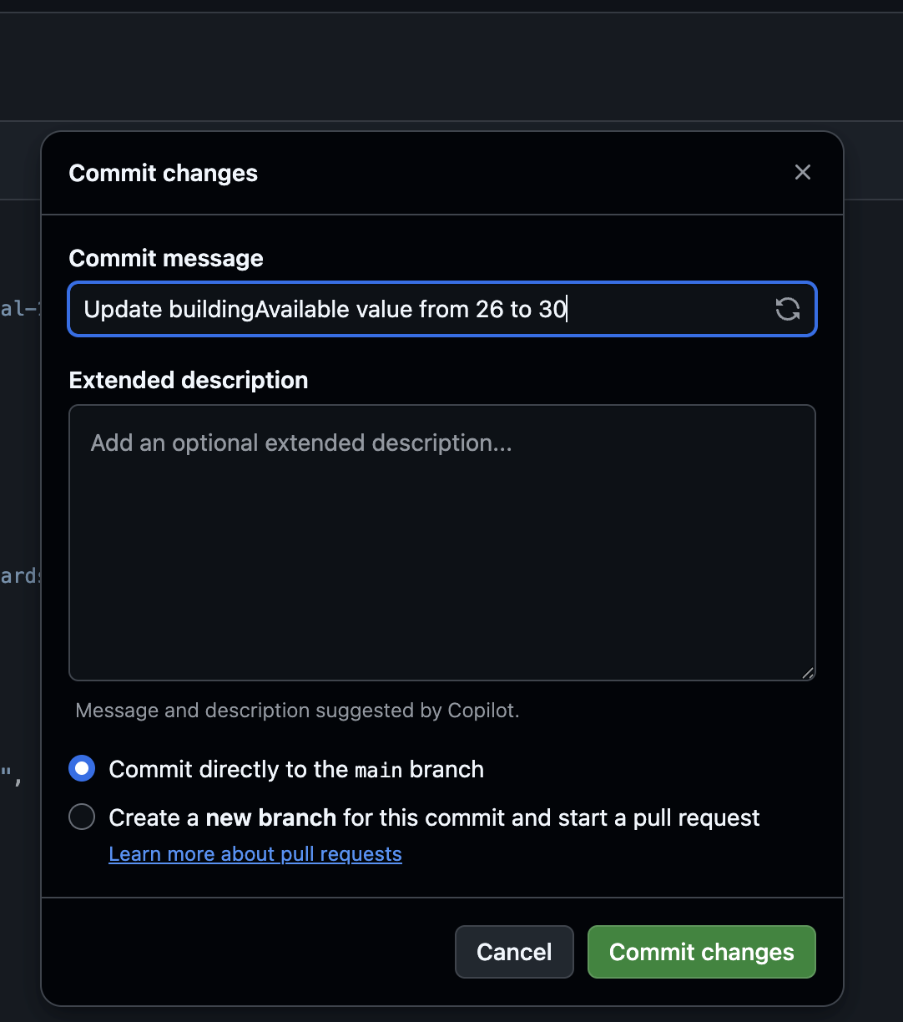

*After this your page should go back to viewing the file and vercel will auto deploy the edit so it will be present on the website.*

1.2 Adding an Image

*To change an image on the website you will first need to make sure the image is in the images folder. On the main Github repository click on the file labeled “TampaPalms”.*

**

*Then navigate to the folder labeled “public” and open it.*



*Next, open the folder labeled “images”.*



*Once in the images folder you will see a button on the top right of the screen that says “Add file”. Click on that and then a dropdown will appear. On that dropdown, select “Upload files”.*



*Once selected you will be brought to a new page that allows you to drag and drop or choose files to add. After selecting your file, comment your change (Ex. added building 1758 front door image) and make sure the commit directly to the main branch box is checked. Once you are done press the commit changes button and your image will be saved in the repository.*



1.3 Changing an Image

*To change an image you will first need to make sure the image is in the images folder (reference section 1.2 for more info). First you will need to open the config.json file on the main page.*

**

*To edit the file you are going to need to click the edit button, found on the top right of the screen.*

**

*After opening edit mode, you are going to need to find what page you are looking to change an image on. Changing an image will be relatively the same process so here is an example. If we want to change the tampa palms logo on the footer of every page we can do the following. First we will navigate to where the logo is used, "branding". Then look for the line that contains the word “image”.*



*This line contains the current TPPC logo. /image/ is the folder and the TampaPalmsLogo.png is the name of the actual image in the images file. To change the current image, you will need to get the name of the image you want to swap in, which can be found in the images folder. To get to the images folder reference section 1.2. For this example we are going to be using the image “Bldg5-004.jpg” found in the images folder.*

**

*After getting the name of the image you would like to use, replace the current image “TampaPalmsLogo.png” with “Bldg5-004.jpg”. It is imperative that the format of the image must be “/image/****Your image name****”. Here is what the complete image swap should look like.  
 *

*After you have finished your change(s) look to the top right of the screen and press the big green button labeled “Commit changes…”. To cancel the changes made just press the button next to it labeled “Cancel changes”.*

**

*A popup will appear telling you to give your commit a message. Give your commit a message corresponding to your edit (Ex. change logo image), and an extended description if appropriate. After you are finished, make sure the “Commit directly to main branch” box is checked and press the “Commit changes” button once more.*

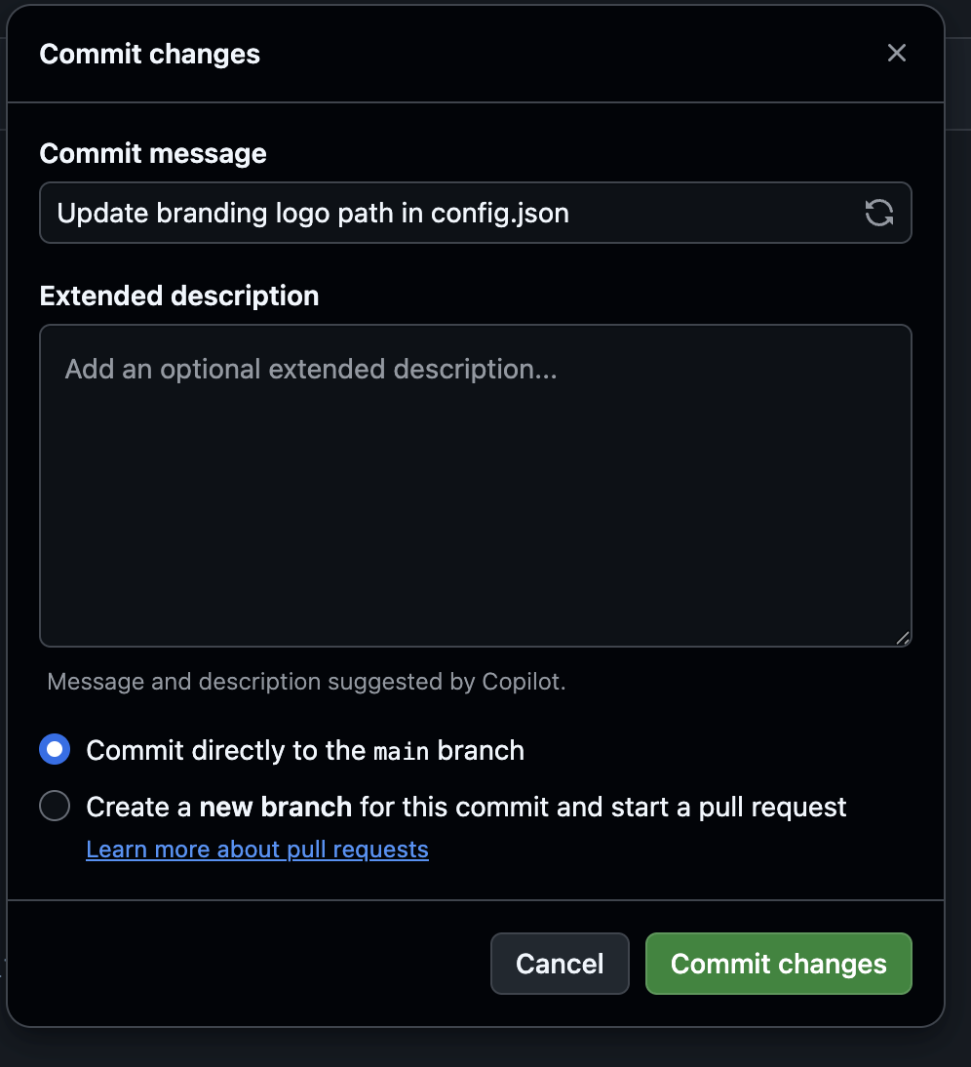

*After this your page should go back to viewing the file and vercel will auto deploy the edit so it will be present on the website.*

1.4 Changing Font Size

*To change the text size in the website you will first need to navigate to the Config.json file in the main page of the github repository.*

**

*To edit the file you are going to need to click the edit button, found on the top right of the screen.*

**

*Once in editing mode you will have to scroll all the way to the bottom until you see the last section titled “typography”.*

**

*Each label in this section, such as h1, h2, body, or button, matches a specific type of text you see on the site, like page titles, section headings, normal paragraphs, or buttons. When you change one of these values, every place on the website that uses that style will automatically update to the new size. Find the label that matches the part of the website you want to change.  
Here’s what each one controls:*

* ***h1*** *→ The biggest page title (like the hero section title on the homepage).*
* ***h2*** *→ Section titles on pages.*
* ***h3*** *→ Smaller headers inside feature sections or card titles.*
* ***body*** *→ The normal paragraph text everywhere on the site.*
* ***small*** *→ Tiny notes or subtitles.*
* ***nav*** *→ The menu text in the navigation bar.*
* ***button*** *→ The text inside buttons.*

*For example if you want all regular paragraph text (body text) on the site to be larger you would simply change the “body” form 16px (pixels) to 18px or larger depending on your preference. The number is the only thing that is changing in this section.*

**

*After you have finished your change(s) look to the top right of the screen and press the big green button labeled “Commit changes…”. To cancel the changes made just press the button next to it labeled “Cancel changes”.*

**

*A popup will appear telling you to give your commit a message. Give your commit a message corresponding to your edit (Ex. change body font size), and an extended description if appropriate. After you are finished, make sure the “Commit directly to main branch” box is checked and press the “Commit changes” button once more.*

**

*After this your page should go back to viewing the file and vercel will auto deploy the edit so it will be present on the website.*

II. Editing Supabase Tables

2.1 Navigating to the Table Editor:

*To get to the table editor, hover over the very left side of the screen, then navigate to the Table Editor tab, this will allow you to add/remove/edit any item within the existing tables*  
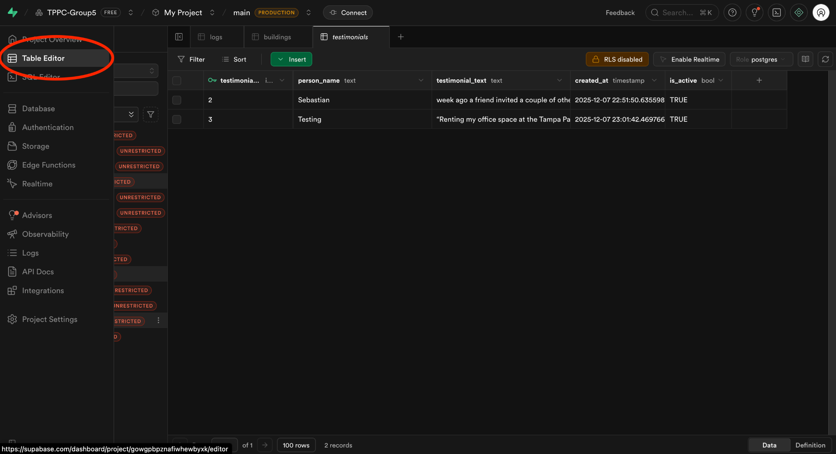

2.2 Editing Any Specific Values:

*In supabase, to update any specific values for an item that already exists, simply double click on that item and the editor for it will pop-up, add desired value and hit enter to save it*

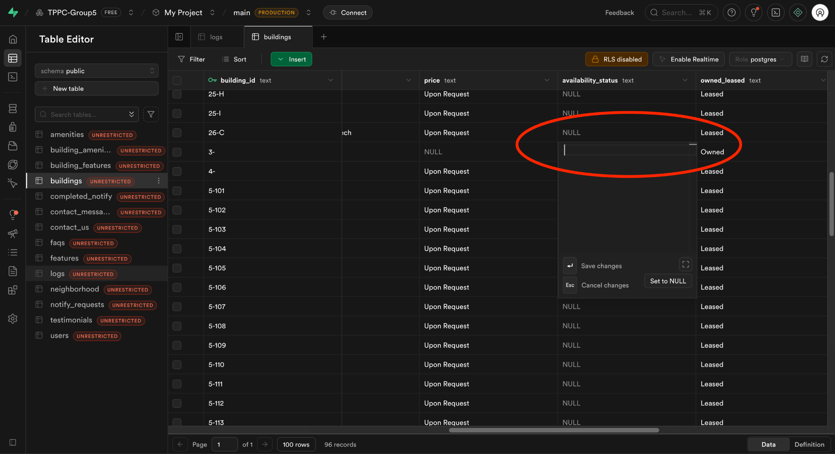

2.3 Building Table:

*In supabase, open the table editor and select the buildings table, and then click the Insert button to add a new row to the buildings table.*

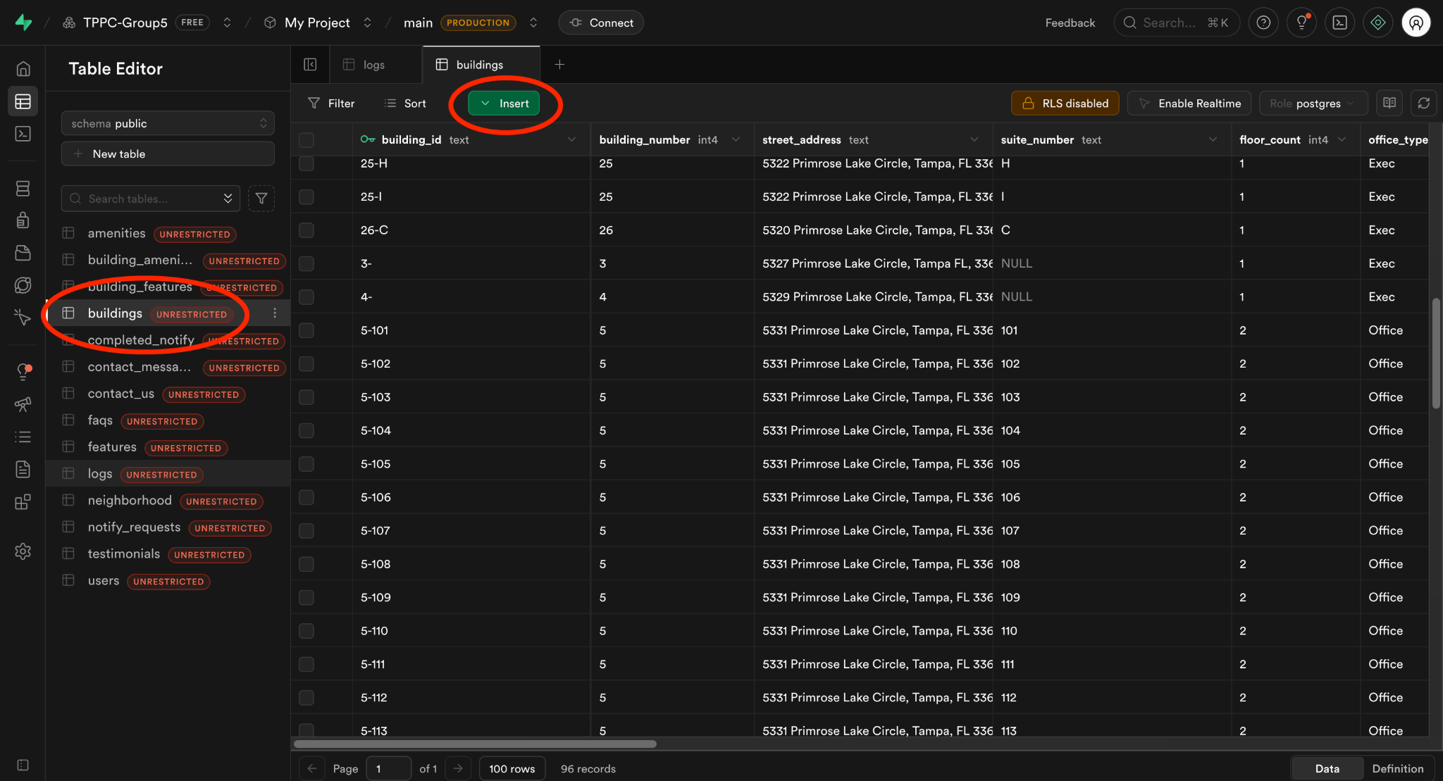

2.4 FAQ Table:

*To add an FAQ, simply select the faqs table from the table editor in supabase, then click insert. After which it will automatically give it an ID, just need to enter a question, answer, and N or Y for whether or not it is executive suites only.*

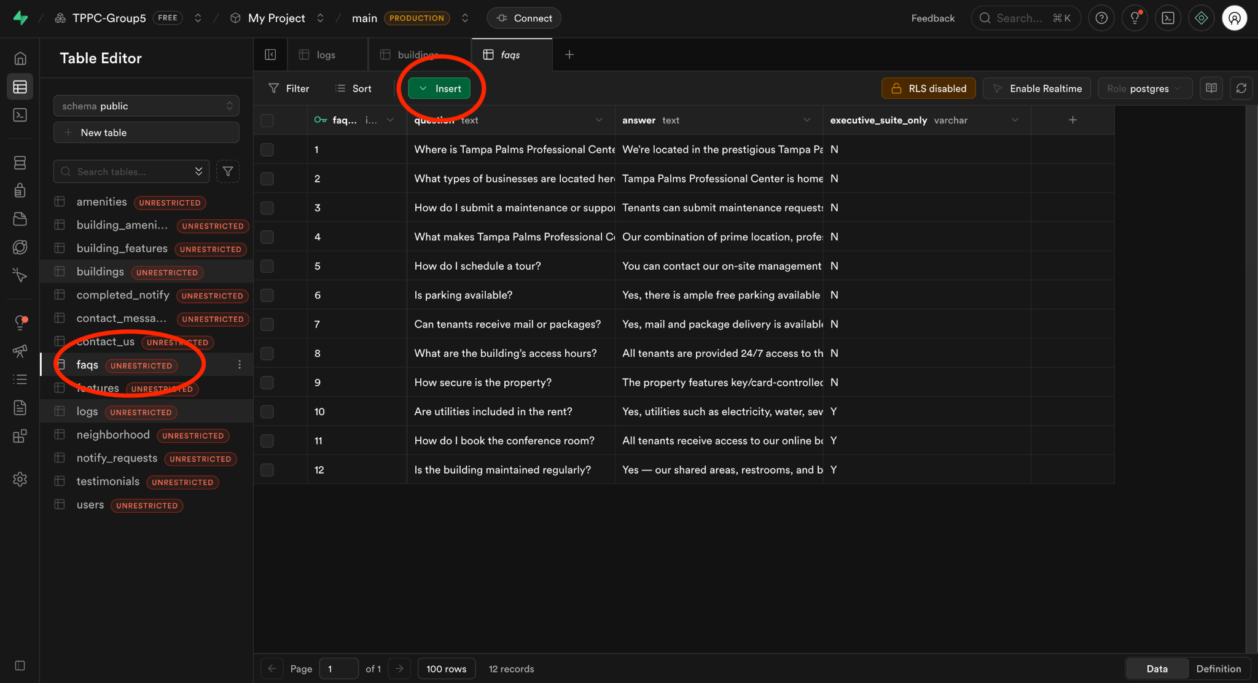

2.5 Testimonials Table:

*Once a tenant submits a testimonial, you can add it to the table in supabase by navigating to the table editor, then clicking on the testimonials table, then the green insert button.*   
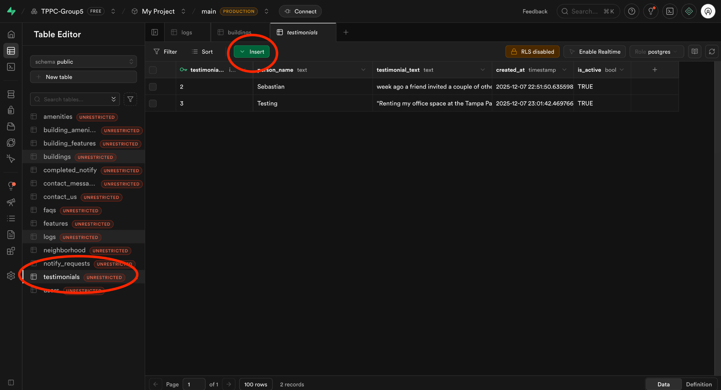

2.6 Neighborhood Table:

*In supabase, open the table editor and select the neighborhoods table, and then click the Insert button to add a new row to the neighborhoods table.*  
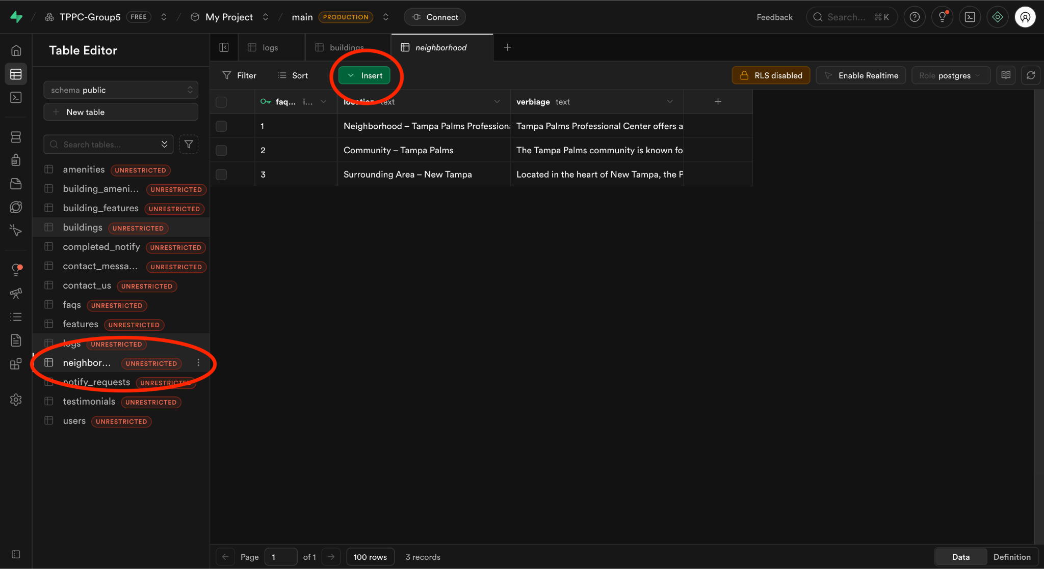

2.7 Adding Features:

*This is a little more complicated as it takes changing multiple tables, but nonetheless easy once you learn how to do it. Also, for our project our features and amenities are hardcoded into the config file, navigate above for that. If you still want to add to the DB, follow the steps below.*

*To start, navigate to the table editor tab and then to the features table, here you can add your desired feature as usual by clicking on the green insert button. Remember/Save the feature_id of the new item you added, as it then helps us link to a building. For this example, we will pretend we just added feature #3 with a feature_id of 3.*

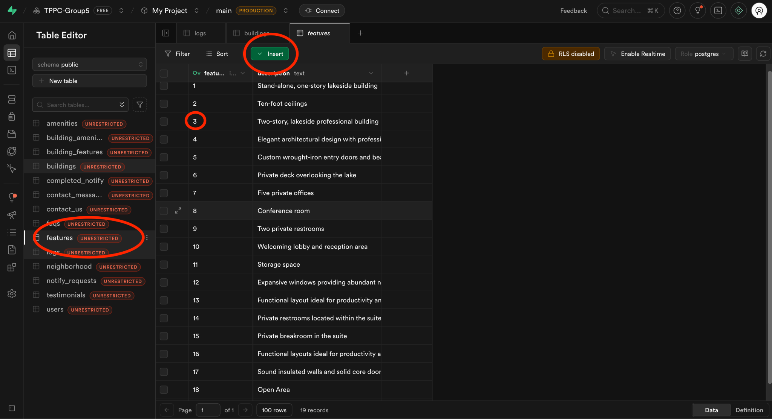

*Then, once the feature is added, navigate to the building_features table to link the said feature to the buildings. Lets say for this example we would want to link our new feature to building one. We also need that buildings building_id from the buildings table, so we will navigate there to find that ID.*

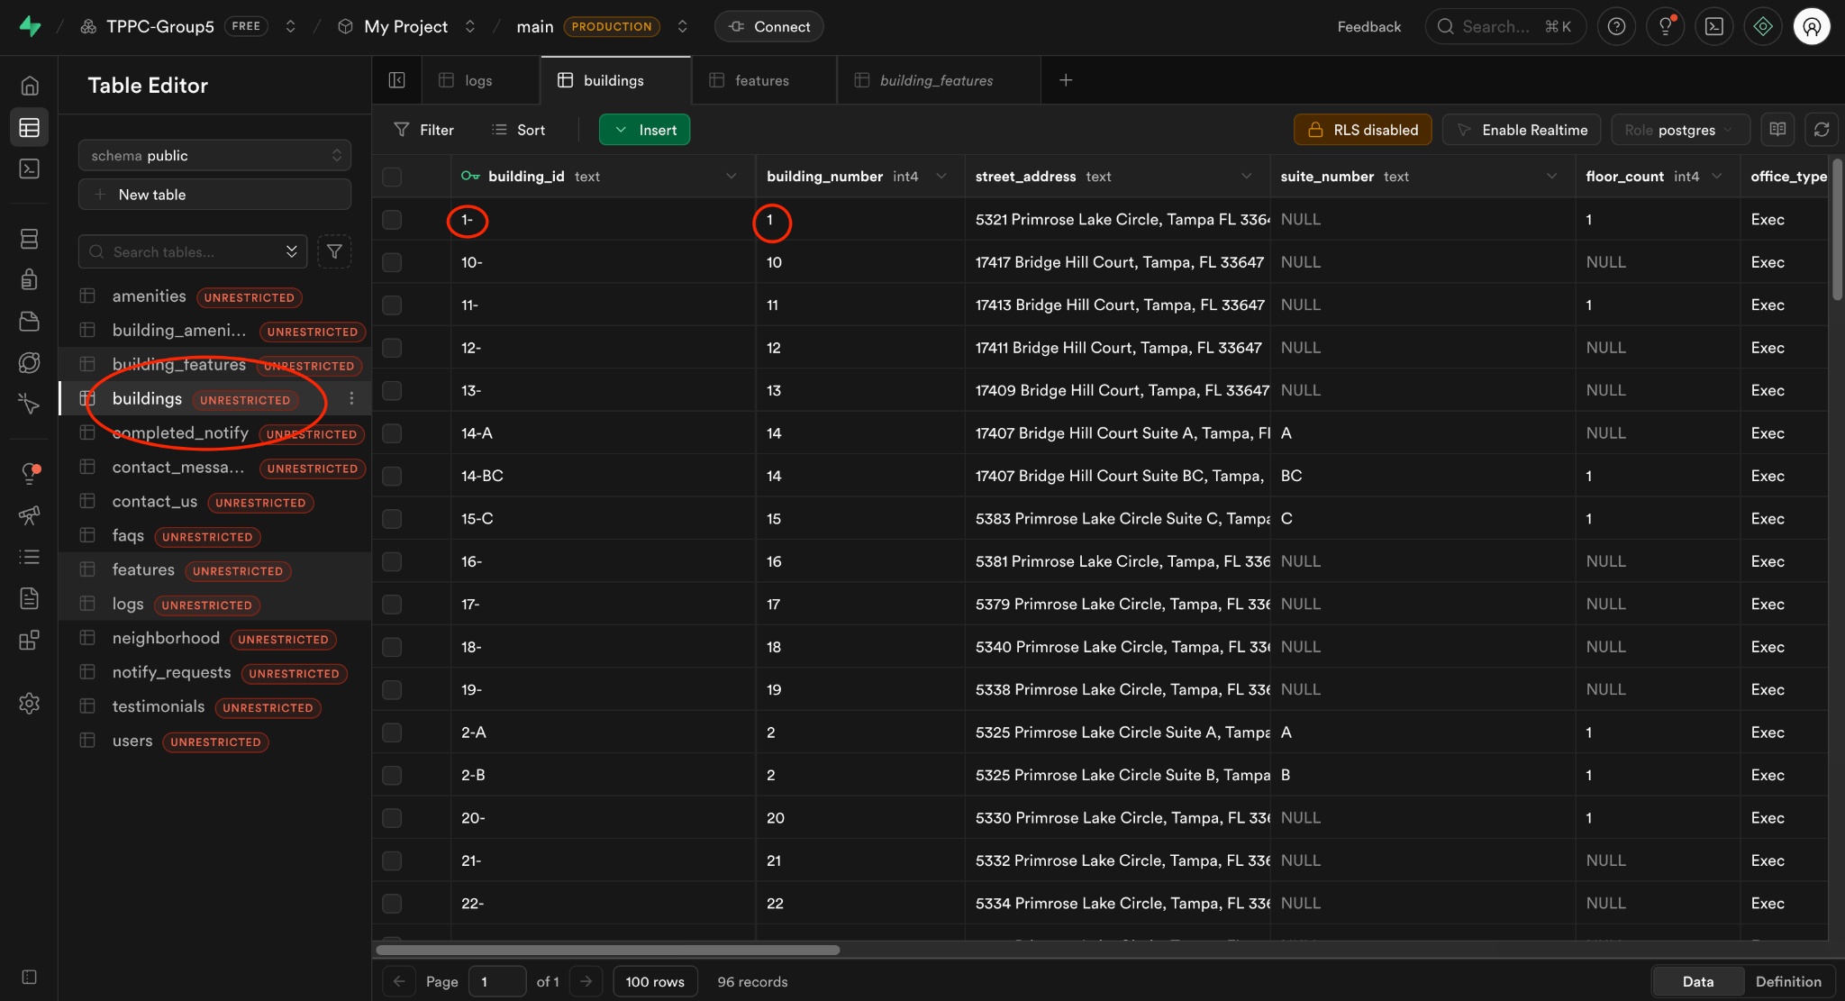

*Note that the building_number and building_id are not the same, we want the building_id. So, in our example, we will use “1-” to link the feature to this building. Now we can navigate to the building_features table and insert a new row by clicking on the green insert button.*

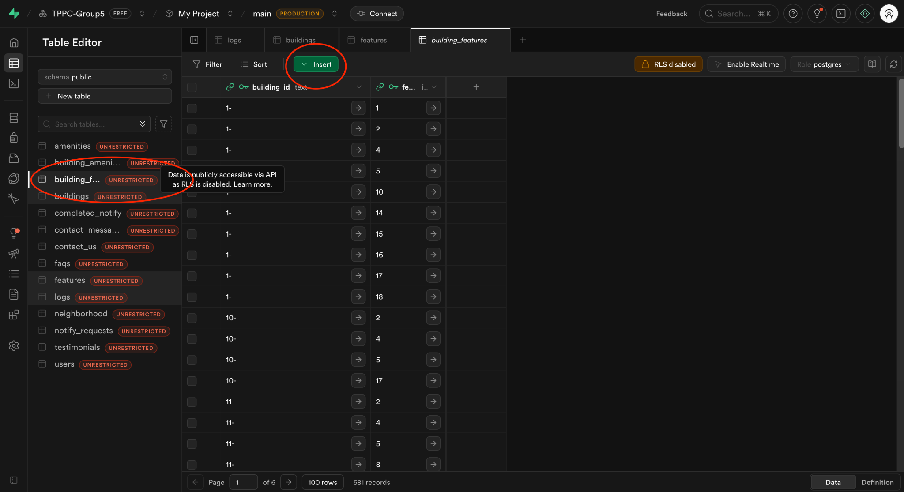

*After clicking on insert, we then enter our building_id (1-) and feature_id (3) into their respect rows and click save. This will then add a newly linked feature to that desired building*

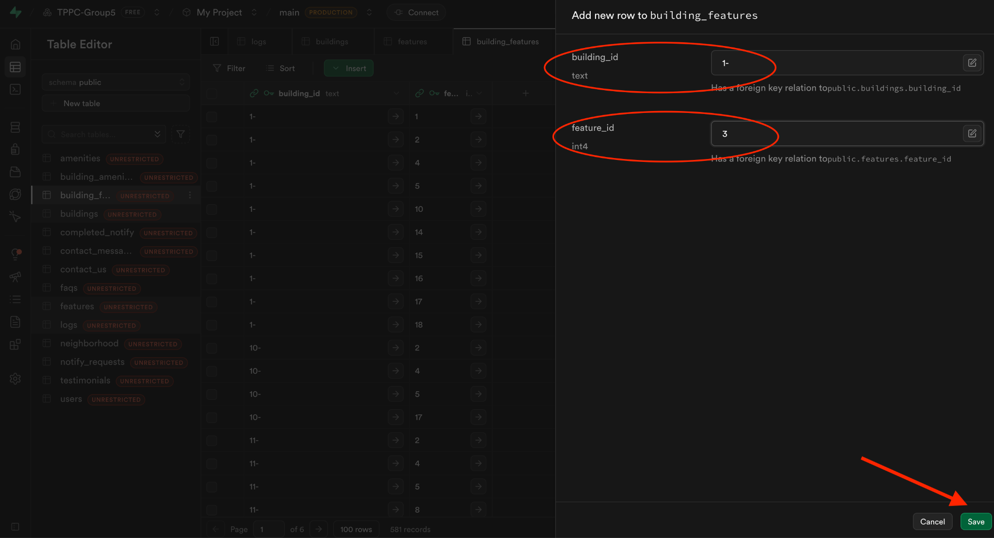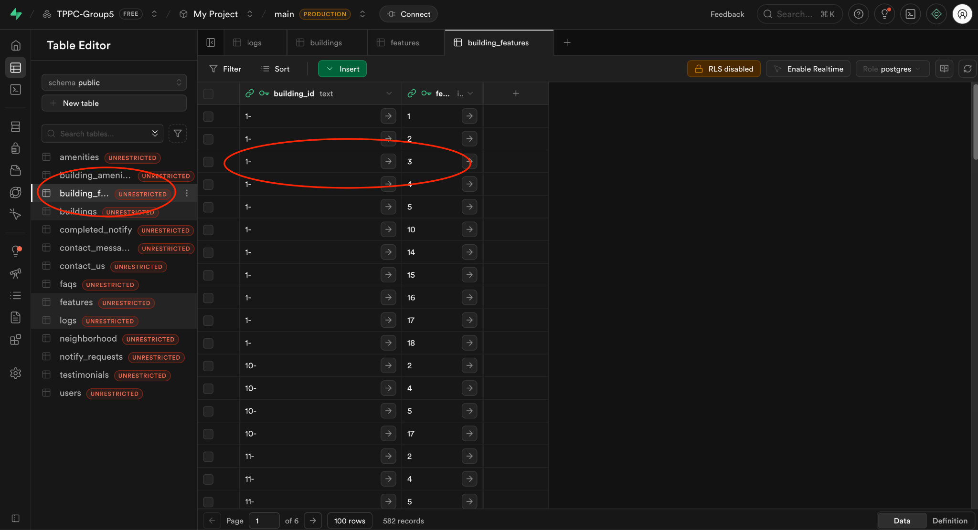

*And you’re done! That is how to add a new feature and correctly link it to its desired building. If you want to link a feature to more than one building, repeat the steps to find that buildings ID, then use the same feature_id to link it!*

2.8 Adding Amenities:

*Adding amenities is the exact same process as for features, just with different tables. Also, for our project our features and amenities are hardcoded into the config file, navigate above for steps on adding to that. If you still want to add to the database, follow the steps below.*

*To start, simply navigate to the table editor tab and then to the amenities table. When there, simply insert your new amenity by clicking on the green insert button, once done, remember/save the amenity_id, as we will need it to link to buildings. In our example, we will pretend we just added amenity_id 9.*

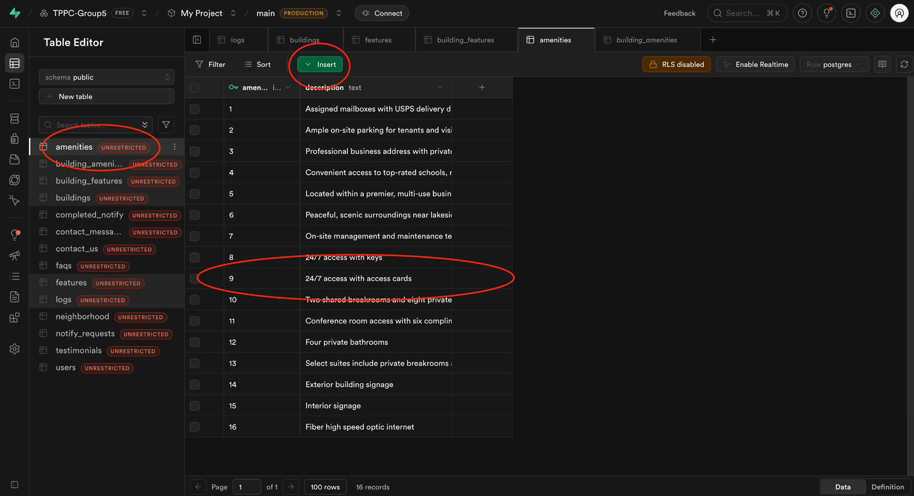

*When the amenity is created, navigate to the buildings table, this is where we will find our desired building to link to the newly created amenity. For our example, we will use building one. We are looking for that buildings’ building_id.*

**

*Note that the building_number is not the same as the building_id, in our case we need the building_id.*

*After that is found, navigate to the building_amenities table, this is where we will link the two. Click on the green insert button to create a new row.*

**

*Once you click insert, simply enter the building_id (1-) and the new amenity_id (9). Then click save, the ids will automatically route to their respective rows in their tables.*

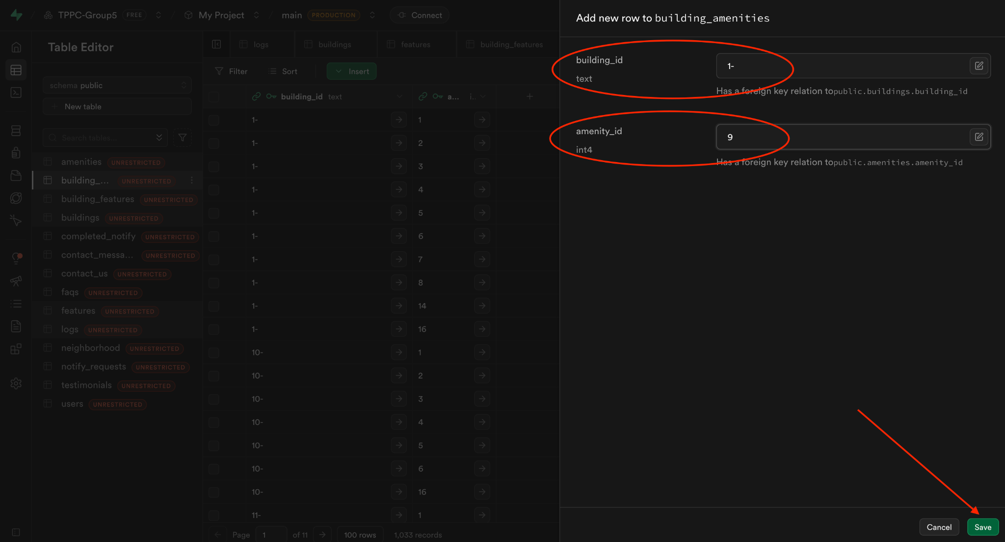

*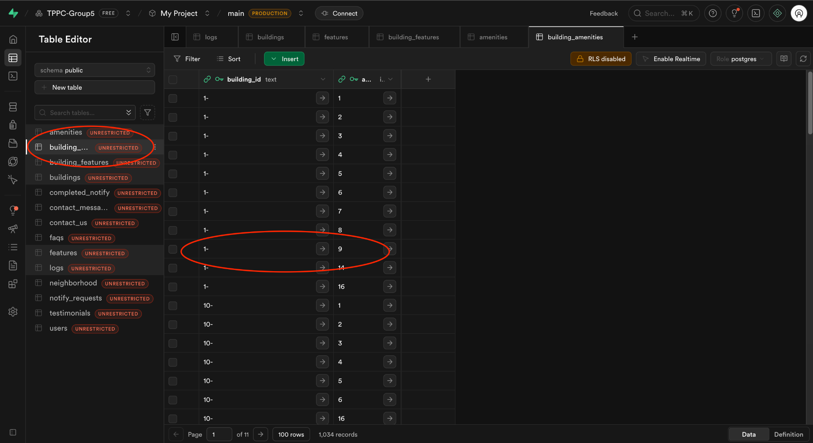  
  
Just like that, you have created a new amenity and successfully linked it to a building. To link more than one building to an amenity, follow the same steps, grab that building_id, then create a new row in which you insert that building_id and the amenity_id.*